Lawn+Care
Management Application
User’s Manual

by
Robert Alden

Table of Contents

Landing Page

Summary: The Landing page is the first page a user will typically see on the site. It serves no major functionality purpose other than providing links to the actual functionality of the application. These links are omnipresent throughout the site.

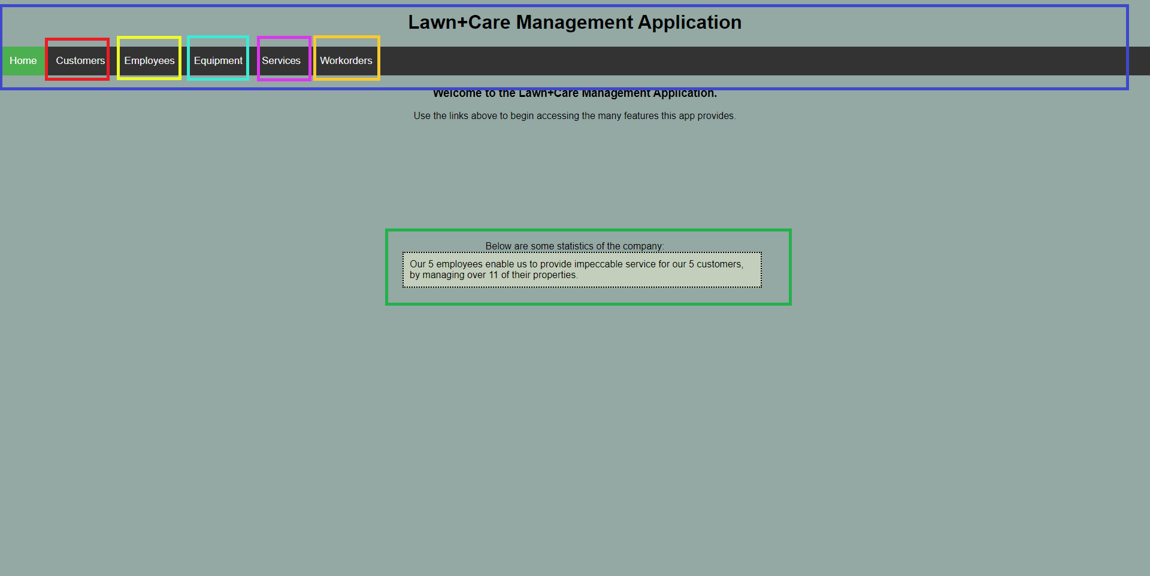
█ - Title Bar
This Title Bar is used to navigate the application. It is present across all pages, and serves as a directory as well as a reminder what portion of the site a user is currently accessing. The active section will be highlighted in a bright green, as opposed to the other links which remain dark.

█ - Customers Link
This link will direct the user to the Customer Management Page. Details for this page will be discussed in the following pages:

█ - Employees Link
This link will direct the user to the Employees Management Page. Details for this page will be discussed in the following pages:

█ - Equipment Link
This link will direct the user to the Equipment Management Page. Details for this page will be discussed in the following pages:
Landing Page cont.

█ - Services Link
This link will direct the user to the Services Management Page. Details for this page will be discussed in the following pages:

█ - Workorders Link
This link will direct the user to the Customer Management Page. Details for this page will be discussed in the following pages:

█ - Statistics Splash
This splash displays basic statistics about the data in the database, limited to just quantities of employees, customers, and properties served.

Customers page

Summary: The Customers Page allows three main actions, adding new customers to the database, viewing existing customer records, and managing those records.

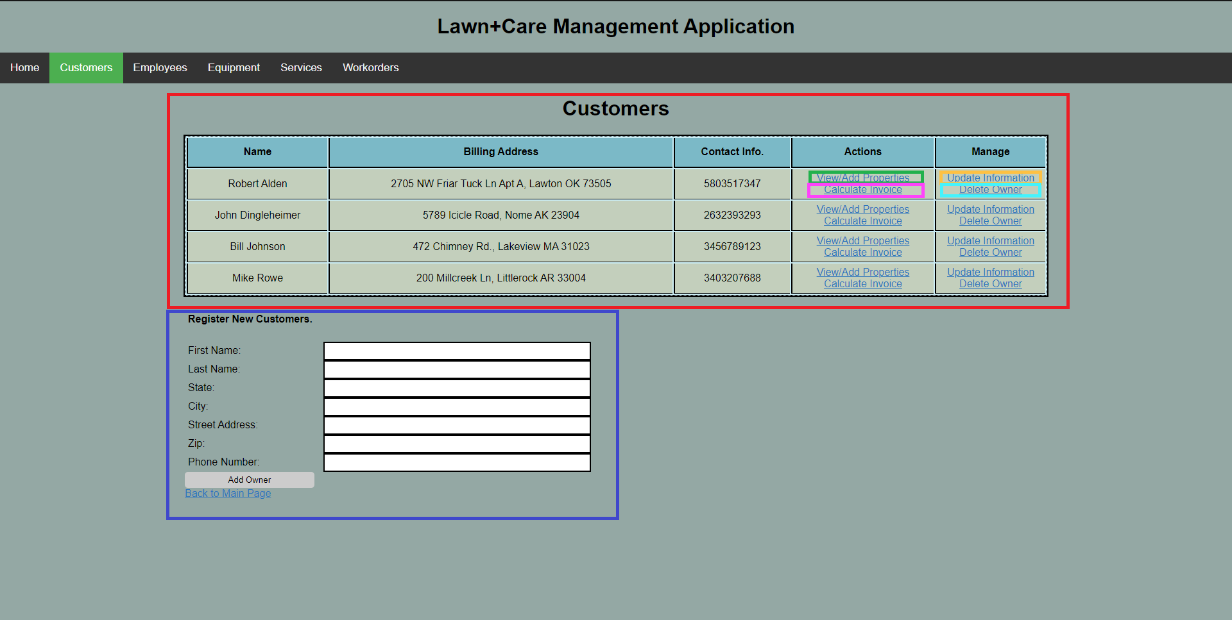
█ - Customer Records
This Table will display all existing customer records in the database. If there are no records, a message will be displayed prompting the user to begin adding records with the form below. For every record displayed, 4 actions can be taken, View/Add Properties, Calculate Invoice, Update Information, Delete Owner

█ - View/Add Properties
This link will direct the user to the Property Management Page, in which the properties that are registered to the customer from which the link was clicked will be displayed. Details for this page will be discussed in the following pages:

█ - Calculate Invoice
This link will direct the user to the Customer Invoice Page, in which a subtotal can be calculated from a range of dated workorders. Details for this page will be discussed in the following pages:

Customers page cont.

█ - Update Information
This link will direct the user to a form nearly identical to the one below the Customer Records section. The main difference is that form will be auto-filled with the existing data in the customer’s record. One or more fields may be changed and resubmitted, as well as submitting no changes at all.

█ - Delete Owner
This link will remove the customer from the database. A confirmation dialog will appear to avoid accidental deletion, as it will cause all properties, and workorders associated with that owner to be lost.

█ - Register New Owner
This form allows for the creation of a new customer record. All fields are required except the “Phone Number” field.
View/Add Properties Page

Summary: The View/Add Properties page allows for the creation and management of properties, as well as viewing any work orders assigned to them in the past.

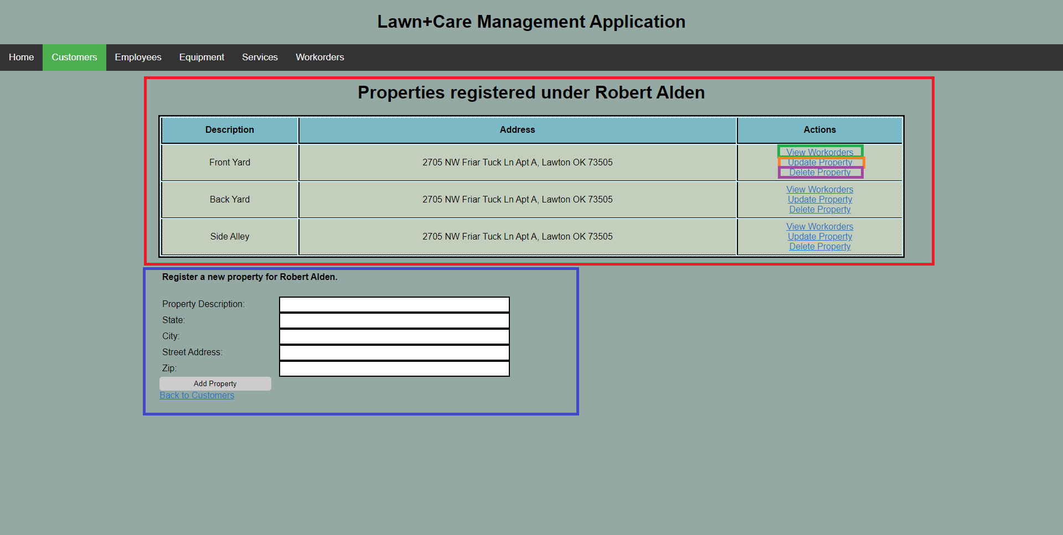

█ - Property Records
This Table will display all the properties currently registered under a given customer. If there are no records, a message will be displayed prompting the user to begin adding records with the form below. For every record shown, 3 actions can be taken, View Workorders, Update Property, and Delete Property.

█ - View Workorders
This link will direct the user to the Property Workorder page, which will display all the workorders recorded for a particular property.

█ - Update Property
This link will direct the user to a form nearly identical to the one below the Property Records section. The main difference is that form will be auto-filled with the existing data in the property’s record. One or more fields may be changed and resubmitted, as well as submitting no changes at all.

█ - Delete Property
This link will remove the property from the database. A confirmation dialog will appear to avoid accidental deletion.

█ - Register New Property
This form allows for the creation of a new property record. All fields are required.

Employees page

Summary: The Employees Page allows three main actions, adding new employees to the database, viewing existing employee records, and managing those records.

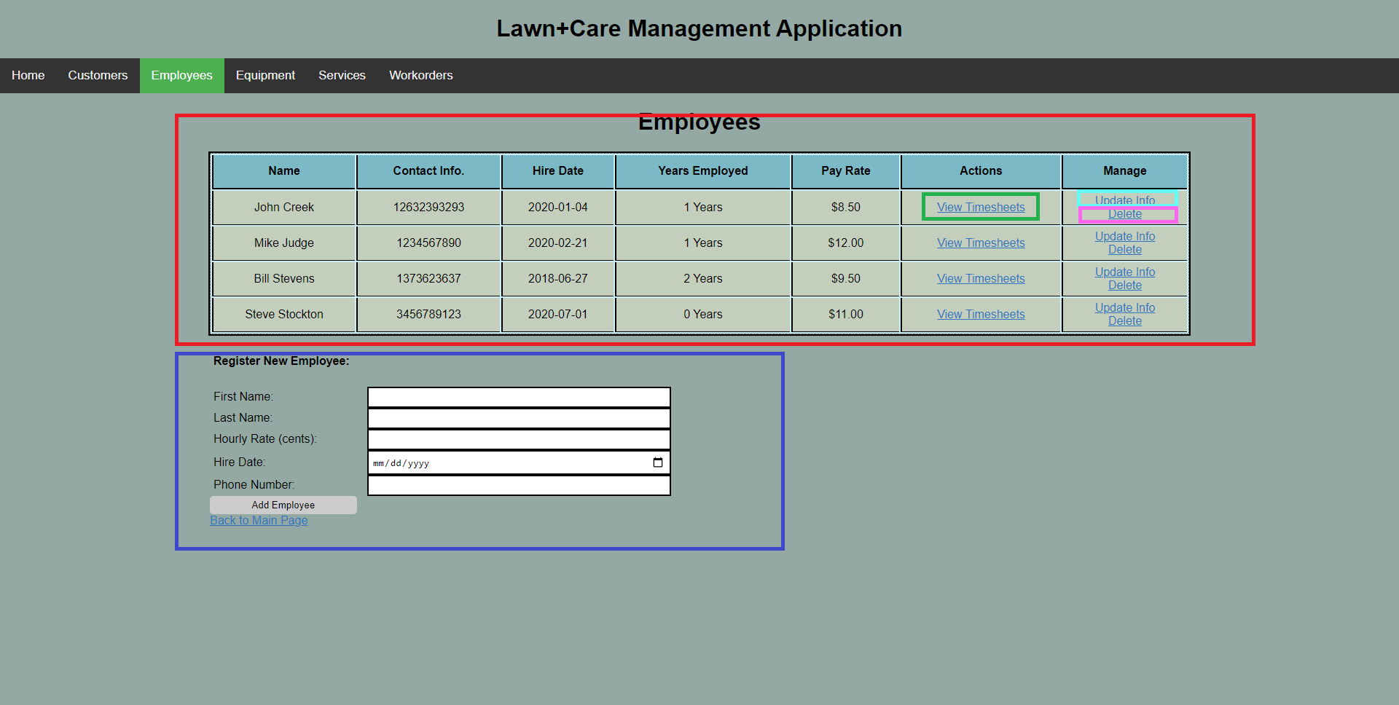
█ - Employee Records
This Table will display all of the employee records. If there are no records, a message will be displayed prompting the user to begin adding records with the form below. For every record shown, 3 actions can be taken, View Timesheets, Update Info, and Delete.

█ - View Timesheets
This link will direct the user to the Timesheets page, which will display all the timesheets generated by a particular employee, to determine payroll.

█ - Update Info
This link will direct the user to a form nearly identical to the one below the Employee Records section. The main difference is that form will be auto-filled with the existing data in the employee’s record. One or more fields may be changed and resubmitted, as well as submitting no changes at all.

█ - Delete
This link will remove the employee from the database. A confirmation dialog will appear to avoid accidental deletion.

Employees page cont.

█ - Register New Employee
This form allows for the creation of a new property record. All fields are required.

